CS 255 System Design Document Template

UML Diagrams

UML Use Case Diagram
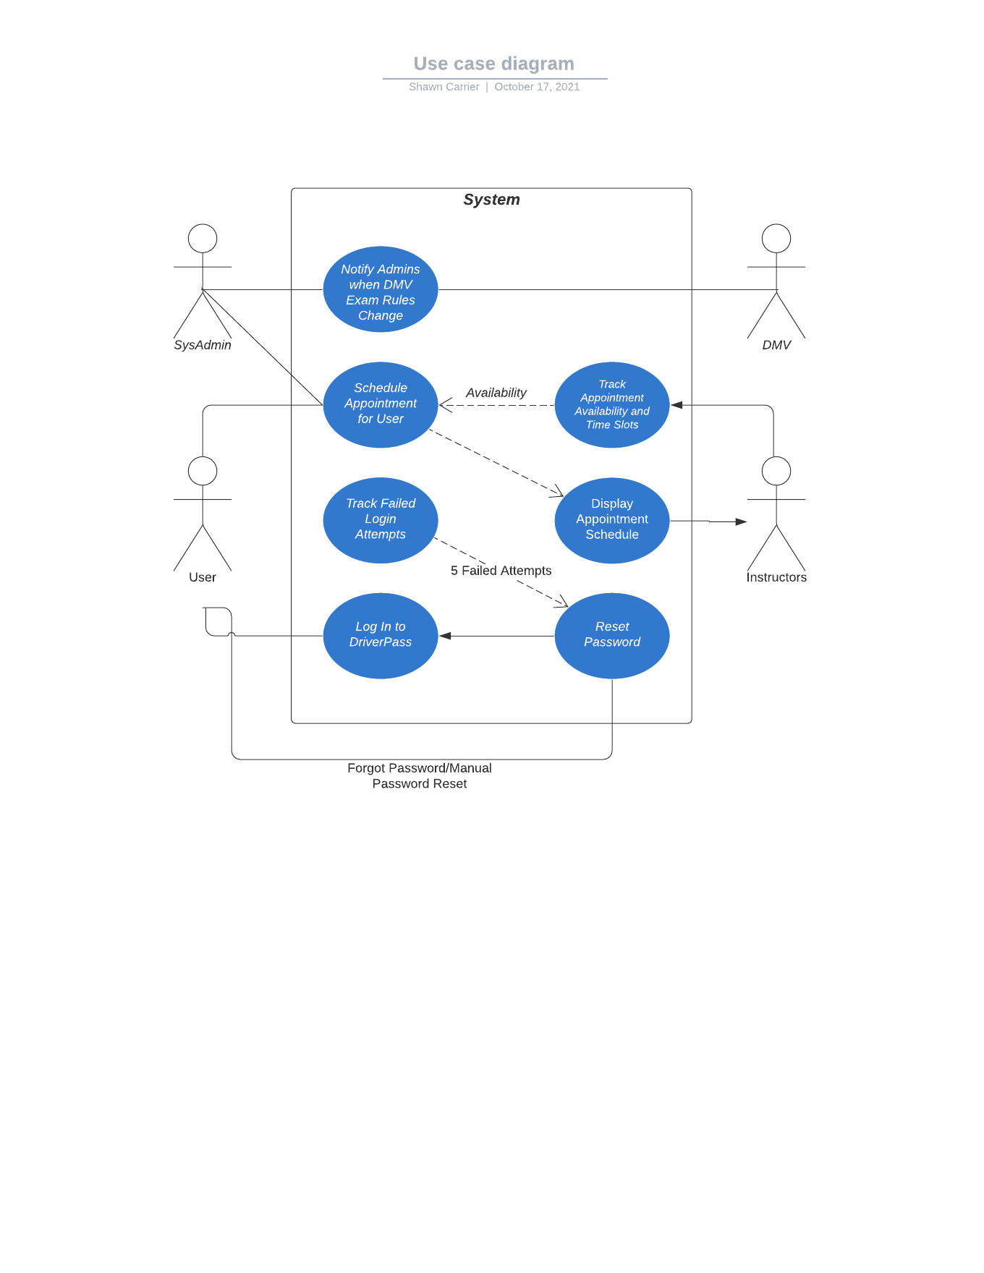

UML Activity Diagrams
Reserving an appointment slot:
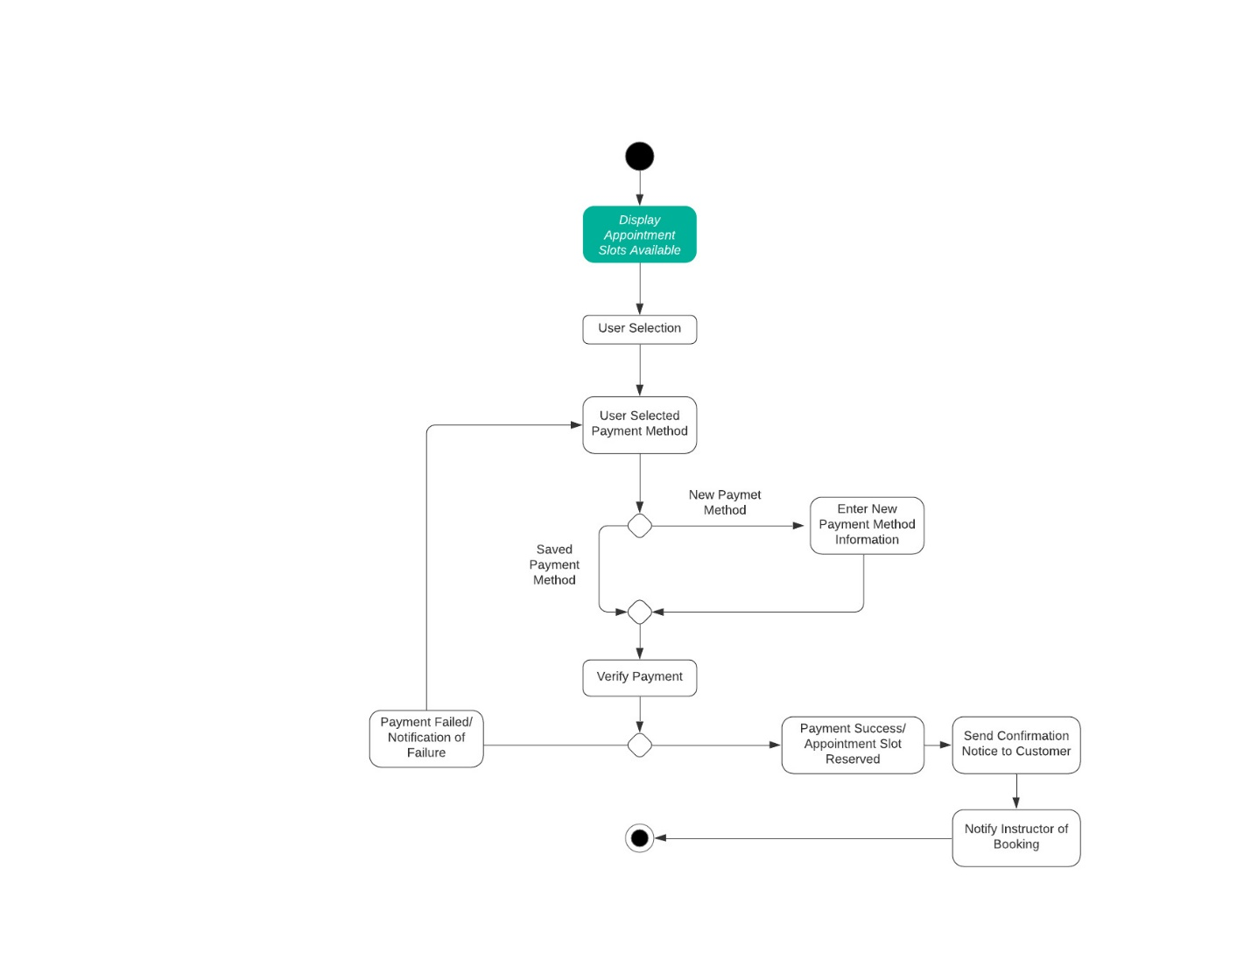

Logging in process:
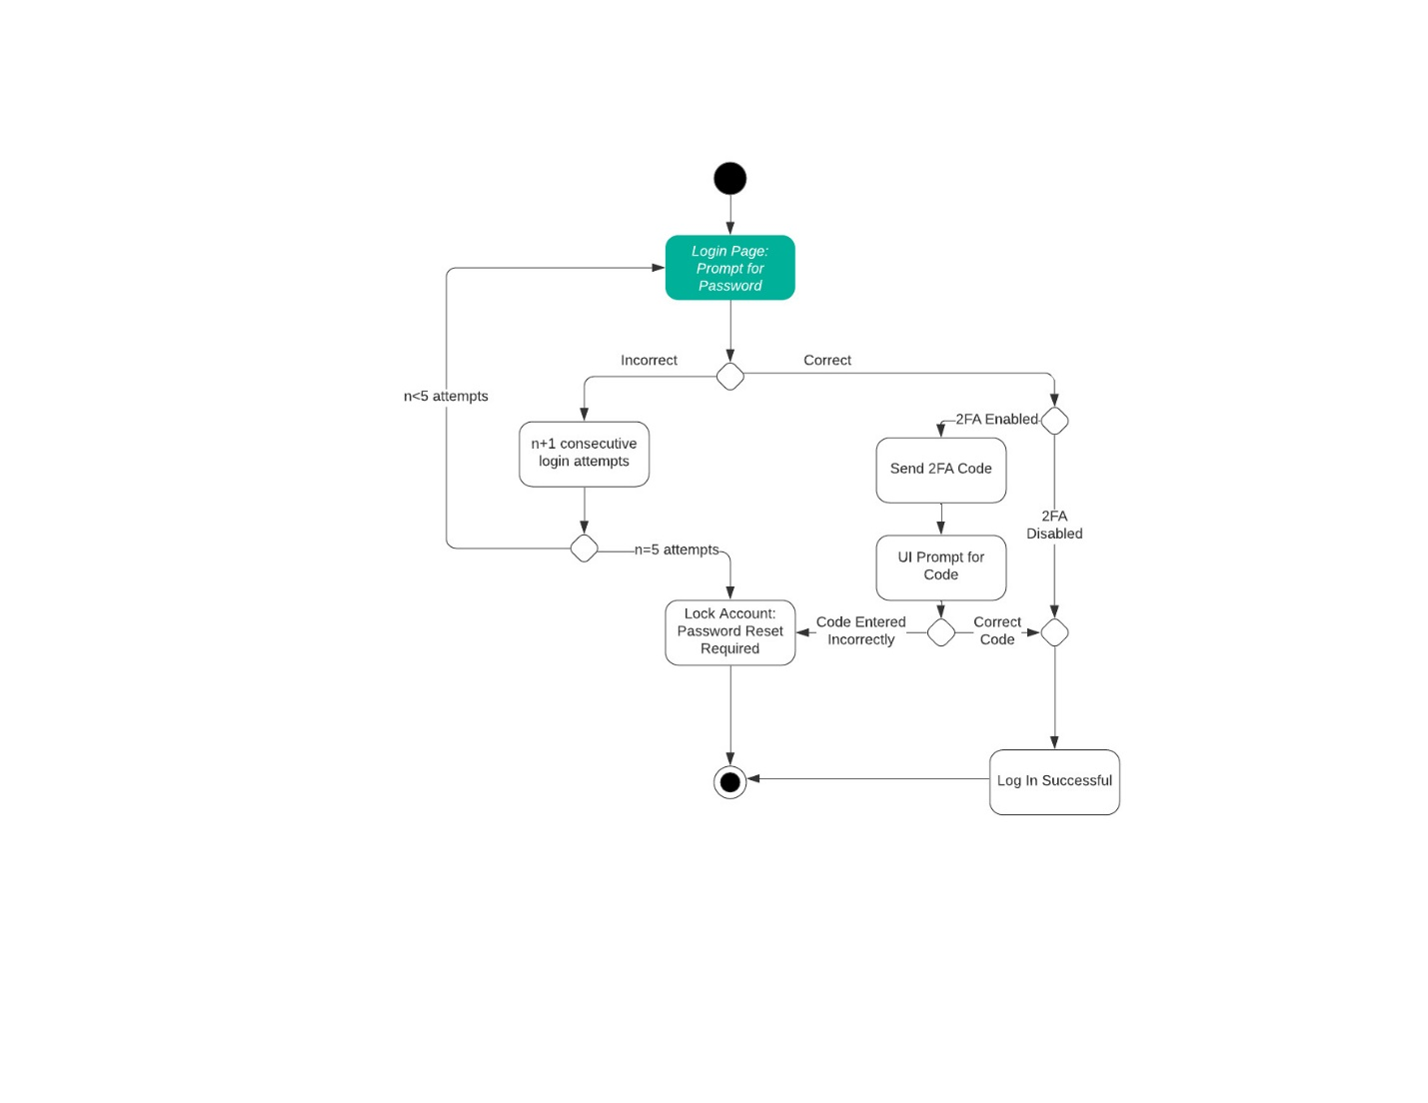

UML Sequence Diagram
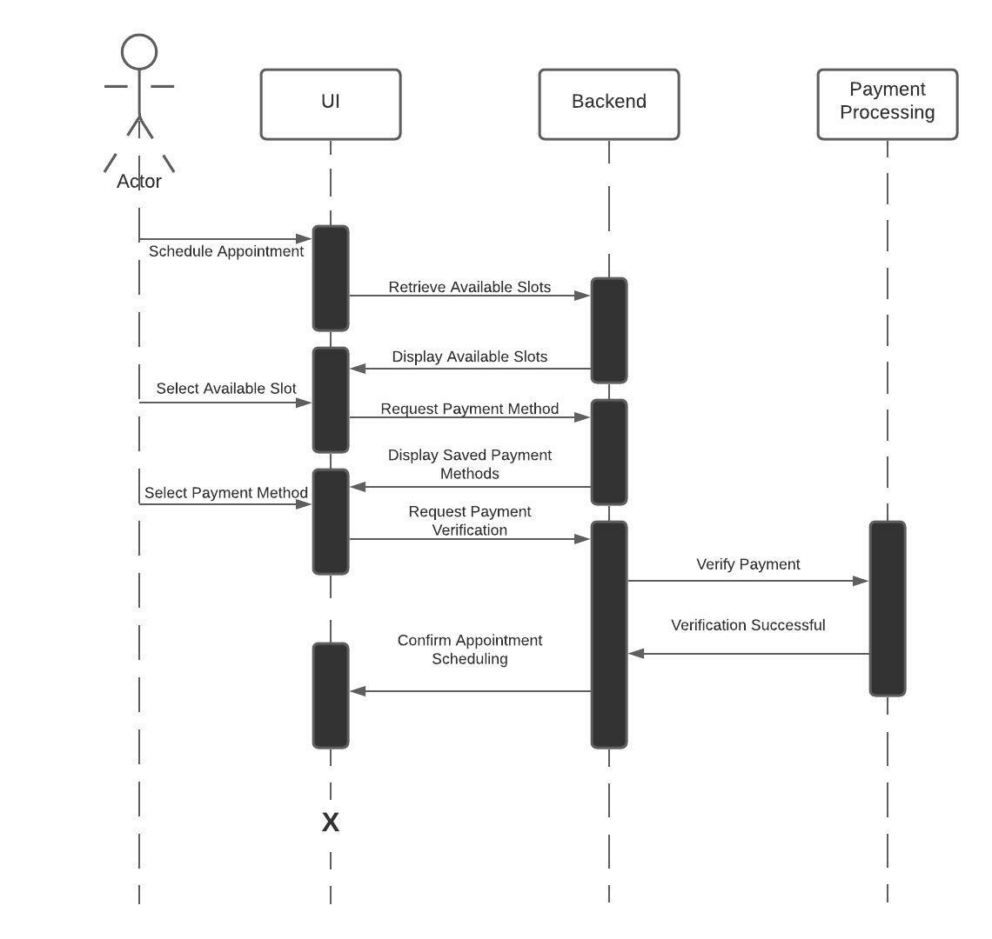

UML Class Diagram
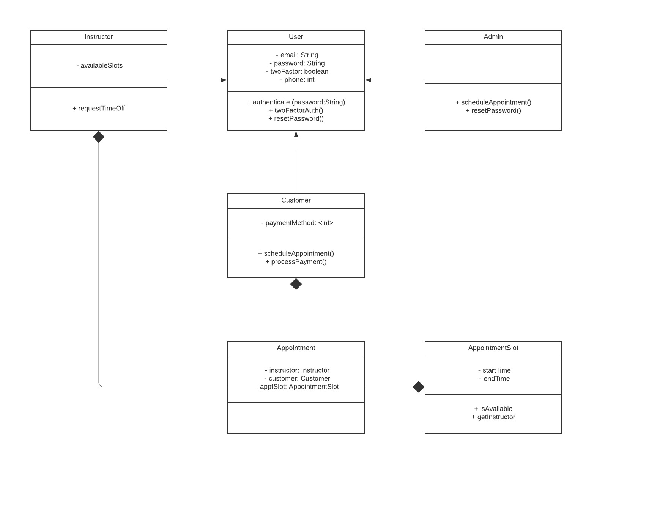

Technical Requirements
The most important consideration when reviewing the UML diagrams above is that the system is going to need a host server machine. This will function as the backend removing appointment slots from the schedule, keeping the schedule up to date, supplying the study materials for the user, allowing the administrators to make changes to the system, and processing payments for services. In conjunction with the host machine, a reliable internet connection is equally important. DriverPass wants the users and employees to be able to access the program from any device if the user has a reliable connection to the internet. This can be the same standard the host should be subject to. Without a steady connection there will be users unable to access the product they may have paid for.
Keeping the server constantly connected to the internet also brings about the threat of hack attempts and server attacks. Security for the server will be just as, if not the most, important features of the service offered by DriverPass. Some students, and employees, will use more personal information for account creation than others. The other factor to consider with security is that the system saves payment methods for future uses. Similarly, with handling payments over the internet, DriverPass will need a system in place to handle that billing and transfer capabilities when moving it to various accounts in their system.
The last specification necessary for the system is an interface for office use, as well as system administrator access for maintenance and repairs. The office use interface will allow the employees to assist customers and users with questions they have as well as aid in web-based functions such as scheduling appointments. The system administrator panel will allow for website updates, server updates, and general maintenance over the systems use.

